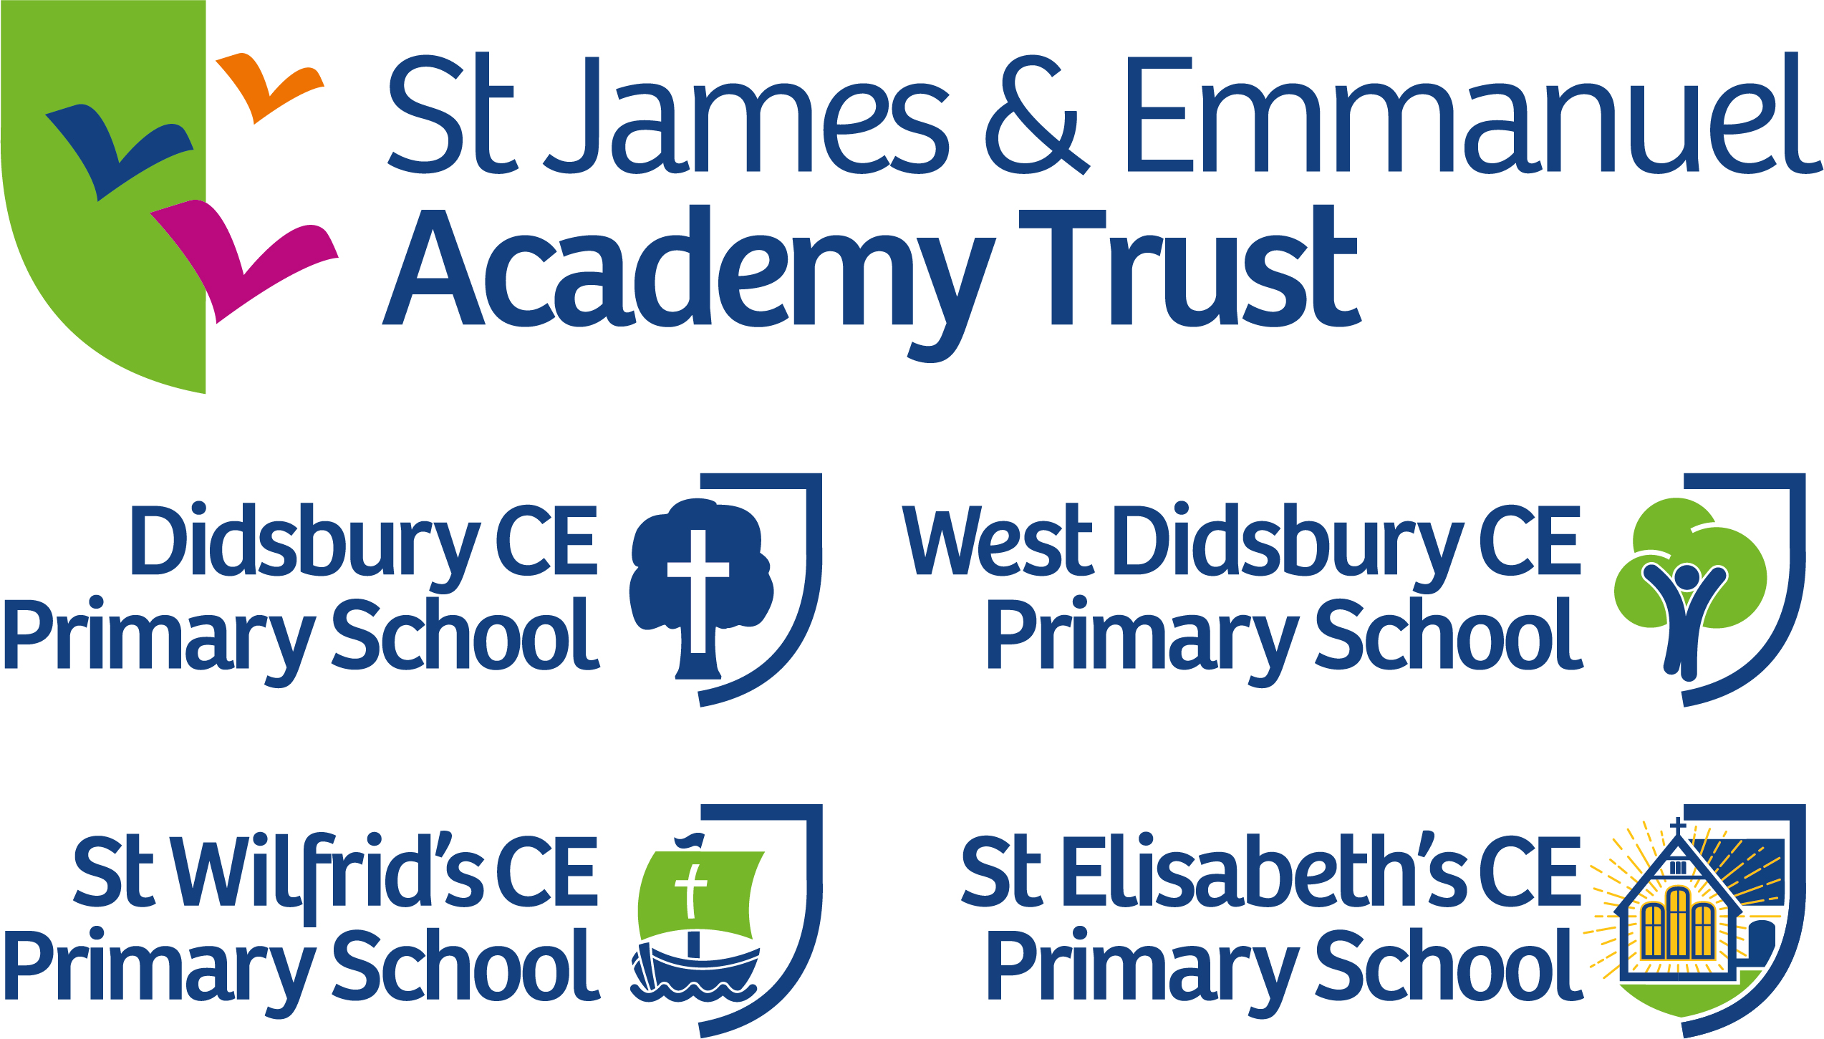

Didsbury CofE Primary School

Local Governing Body Meeting
Tuesday 8th March 2022 7.30pm
Draft Minutes

Present:
Catriona Arundale Foundation Governor
Simon Ball Head of School
Kate Catling Parent Governor
Paul Good Chair (MDBE)
Augustine Ihm Foundation Governor
John Janulewski Foundation Governor
Matthew Lee Foundation Governor (remotely)
Sam Morgan Staff Governor (remotely)
Philip Robinson Parent Governor
Matt Whitehead Executive Headteacher

Apologies
Abbie East Foundation Governor
Joyce Thom Foundation Governor (remotely)

In attendance
Kathy Crotty Clerk
Emma Lomas Writing Lead

Any text in red bold italics represents a Governor question (Q); challenge (C); Governor and/or clerk support (S). Black bold upright represents decisions and actions.

1. Welcome, Introductions & Opening Prayer
Governors were welcomed to the meeting by John Janulewski. Augustine Ihm led the opening prayer.

2. Apologies for Absence
Apologies were received and accepted from Joyce Thom and Abbie East.

3. Declarations of Non/Pecuniary Interest
- Catriona Arundale; Phillip Robinson, Kate Catling, Abbie East, and Matt Lee, all have children in the school. Paul Good has one grandchild in the school and John Janulewski has two grandchildren in the school.
- There are no other declarations other than those listed on the school website

4. Presentations – Maths and Writing
Maths
Mrs Lugsden is the Maths lead and the HoS explained she could not attend this meeting due to health issues so he will summarise the report and this will be shared with Governors via Governor Hub after the meeting.
The DfE identified the content of the catch-up sessions and “ready to progress” was instigated. This was a maths starter which also included previous learning and ensures fluency. The profile of maths was raised, and the initiatives were outlined. The school has regular times tables activities, the school uses Rock Stars and has maths competitions. In February 2022 the school used the NSPCC (National Society for the Prevention for Cruelty to Children) number day and this involved identification of where maths occurs elsewhere in the curriculum. There has been a maths walk indicating much high quality teaching. The displays were under-utilised and since then all classrooms except Yr6 have a maths working whiteboard. These working walls have proved to be a useful teaching aid.
Governors were invited to email Mrs Lugsden if there are any questions.
Q: Can these initiatives be made accessible for children at different levels?
Yes, in KS1 there are different tasks for challenges and all work is differentiated.
Q: Is there symbolic reasoning?
Symbols such as algebra would start in Yr5 with puzzles.

Writing – Emma Lomas
Emma presented in March 2021 on writing and there is still an impact of lost learning from the pandemic. Spelling Shed is a new scheme introduced which is also used at WDCE. This scheme enables electronic resources. There used to be different spelling groups, but this was not possible when the school needed bubbles. Spelling Shed has proved popular with class teachers and there are more spelling games and a wider range of resources. Each week there is a new pattern of new words which are easier to learn.
The school is offering after-school sessions which include writing, these are run by school teachers. The training for the tutoring was generic and the school is now at week eight out of fifteen weeks.
The core writing skills are now becoming embedded. There are consistent symbols being used throughout the school. The school is refining skills and there is much recall and retrieval.
Emma Lomas and Emma Hooson have attended writing moderation and it seems the same standard will be expected for this years SATS as this will give an indication of the effects of the lockdown on children’s learning.
Q: Is the assessment based on what the children write or how they write?
The assessment is a combination of the two, handwriting and spelling are included. The moderation will look at writing across a range of genres.
Q: Has the pandemic affected what the children write or how they write?
The children have been affected in how they are writing, the coherence and basic sentence structure is missing. This was more evident in September 2021, and this is less so now.
Q: Do the baseline assessments provide evidence to support the view that writing has been the most impacted?
Yes, a writing assessment occurred in the second week after the children returned. Maths progressed quicker and reading was least impacted from lockdown.
The staff are undertaking moderation of writing with schools in the Didsbury cluster group meeting and other Trust schools.

Next week the staff are receiving training on dyslexia. There have been more children screened outside of school and the school is receiving recommendations about how to help the children. This training will refine practice and will be beneficial to all children.

Subject leads across the Trust have met and poetry was identified as an area for improvement in the curriculum mapping. Poetry can be made more explicit and a progressive approach will be taken. This might create opportunities for free writing and specific teaching. Allan Torr the QA was asked for recommendations, and he provided a comprehensive list of classical poetry. Governors noted the culture of this city is the spoken word, including performance poetry. The classical and contemporary range will take into account the gender and cultural heritage of the author. There is already a poetry reading curriculum and this now needs to be used for writing.
Governors noted the newsletters include children’s poetry which have been remarkable.

5. Minutes of Previous Meeting held 18th January 2022 & Matters Arising
Governors formally approved the minutes of the meeting held 18th January 2022 as an accurate record subject to the correction of Andrew Simcocks name.
Action: Governors to contact Paul Good by the 28th January 2022 to indicate their availability for the Headteacher recruitment panels.
This has been actioned.

6. Update on Headteacher recruitment
Governors were informed the recruitment panel only shortlisted one candidate during the first recruitment round so decided to readvertise using TES (Times Educational Supplement). This has resulted in four new applications. The applications include two current headteachers and the shortlisting of the new applicants will be on the 15th March 2022. This means there has been in total seven applicants and it is hopeful that a number of these applicants will progress through to interview.

7. Head of School – verbal Report
Attendance update
Attendance is strong at 94.5%

School led tutoring update
The school led tutoring is progress well.

Staffing Update
The school has found it difficult to recruit lunchtime staffing, and has recruited a cleaner.

KS1 and KS2 end of key stage targets/predictions
The last assessments were in 2019. The results this year are expected to dip, the children have missed 23 weeks of traditional class based learning and the predictions are lower than usual. Most predictions identify approximately 75% of children are expected to meet the ARE (age related expectations). The post-covid phonics screening test in Yr1 were delayed by six months until the children were in Year 2. In those phonic screening tests this school did very well and results were well above the national average. The expectation is the national average for the STAS tests will be lower. NFER were undertaking some practice moderation tests and this might affect the thresholds. Staff in primary schools have not been informed of any adjustments to the assessments.

In the Year 6 SAT tests this school was placed in the top 250 schools in whole country for two years in 2018 and 2019. This is not expected to occur this year. The children continue to do well and are making progress . This cohort is not expected to perform as well as previous cohorts but are expected to be above the national average giving excellent progress measures from their Yr2 assessments.

8. Behaviour and Safety update
The Executive Headteacher has undertaken the SCR (single central register) checks. The children understand how they are helped to be safe, and the school was identified as a happy place. The ‘All About Me’ survey has been taken by all children; this has been followed up by staff. This focuses on happiness, safety and friendships in school.
Q: Is there a staff equivalent?
There is a Trust staff questionnaire which includes wellbeing and a specific wellbeing questionnaire. There is also a mental health wellbeing group who have audited staff and children. Kate Catling offered to join this group. Kate has met with the wellbeing governor Felicity Bradley at WDCE.

9. Executive Headteacher updates
Finance
The meeting occurred this morning and the report will be uploaded after this meeting. This years budget has been revised. The first draft of the next years budget has been created; the GAG (general grant allocation) has been issued. The Trust originally submitted to the EFA an in-year surplus of approximately £20,000 and there has been additional expenditure on staffing since then of about £43,500. The revised budget will show an in-year deficit but the healthy carry forward allows for this. The school will continue to carry a surplus which remains over 10%.

The first draft of the new 2022-23 budget includes an additional schools supplementary increase, DCE will receive just under £30,000. NI and energy costs are expected to wipe out this additional income. The initial budget planning is positive. There may be optimistic assumptions, and the budget forecasting can change. The new leadership are inheriting a healthy budget surplus.

Premises Update
The school will contribute £50,000 to the repair of the wooden windows, the school has submitted a CIF bid of £200,000. The minus figure in the revised 2021-22 budget includes this contribution. Planning permission has been sought and it is hoped if the bid is successful this can occur this summer holidays.
Governors were informed the site manager will remain in post for one more year.

Trust Updates
Joint inset days are occurring, joint moderations, and joint staff training will continue to occur remotely. John Barrett the new CEO will be visiting the school and Governors were invited to attend on Thursday 21st April at 9am.

Governors noted this money is for the current children and yet the rising costs means there has to be cautious approach to the finances. The government is front loading this additional supplementary grant. Rising costs would affect all schools and this school would be cushioned compared to other schools. The school carried forward £200,000 but £90,000 was from Kids Club and without that extra income, the carry forward would be greatly reduced.
Q: What is the rationale for fundraising for the new reading scheme when there is a healthy budget?
The fundraising is for top-up funding, the school will contribute up to £10,000 to revamp the reading scheme. The funding is also for the phonics scheme. The parents fundraising will support the school expenditure.
Q: What are the two phonics scheme being explored?
“ReadWriteInc” and “Unlocking Letters and Sounds”. These are both fully decodable and are synthetic programmes as required.

Formal thanks were given to Jo Sproson and Sarah Storey for their work on the budget.

10. Governing Body Matters including:
Any training undertaken
Paul Good attended the Trust INSET day and a safeguarding conference run by One Education giving fresh insight into issues.

Link Governor reports
There were no link governor reports for this meeting.

11. Policy approval
Communications Policy
This is not a statutory policy and was last approved in 2019. The HoS has worked with the SLT (senior leadership team) and this policy will be shared with staff after approval. Updates include google classrooms and using emails. There is more online communication than previously. Governors noted the weekly newsletter was well received and is an effective communication method.
Governors formally approved the Communication Policy

The Staff Governor reported staff feel the year group emails are detrimental to their work-life balance and often these emails from parents are replacing communication that should be coming to the office or waiting for the next parents evening. Staff want to return to no class emails as happened before the pandemic.
The HoS emphasised the automated reply informs parents urgent business must go to the school office. It was explained even though staff do not have to answer immediately, the volume of emails is time consuming. The expectation from parents is felt to be too high.
Action: The HoS will arrange to change the automatic reply to direct urgent messages to the office and this will be monitored.

Q: Governors asked who maintains the school Facebook?
Sam Morgan maintains this and other teachers contribute.

12. Date & Times of 2021/22 Meetings
Tuesday 3rd May 2022 at 7.30pm - in school meeting
Tuesday 28th June 2022 at 3.30 (meet the children)

13. AOB
Q: Governors asked for an update on the new Covid guidelines
The HoS explained the regulations have been replaced with guidelines and the expectation is that covid is regarded as a transmittable illness and isolation is still recommended, this however cannot be enforced.

14. Closing Prayer
Augustine led the closing prayer.

Signed…………………………………………………………….
Mr John Janulewski (Vice Chair)

Date………………

Meeting closed at 9:15pm

Summary of actions
- Action: The HoS will arrange to change the automatic reply to direct urgent messages to the office and this will be monitored.

