Charanga Music scheme – Year 6 Knowledge and Skills Assessment Overview

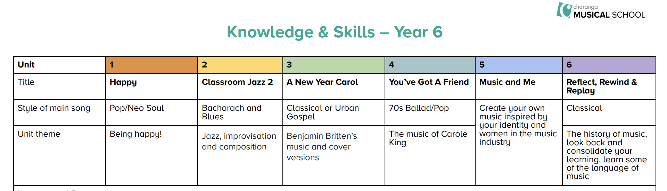

Charanga Music scheme – Year 6 Knowledge and Skills Assessment Overview

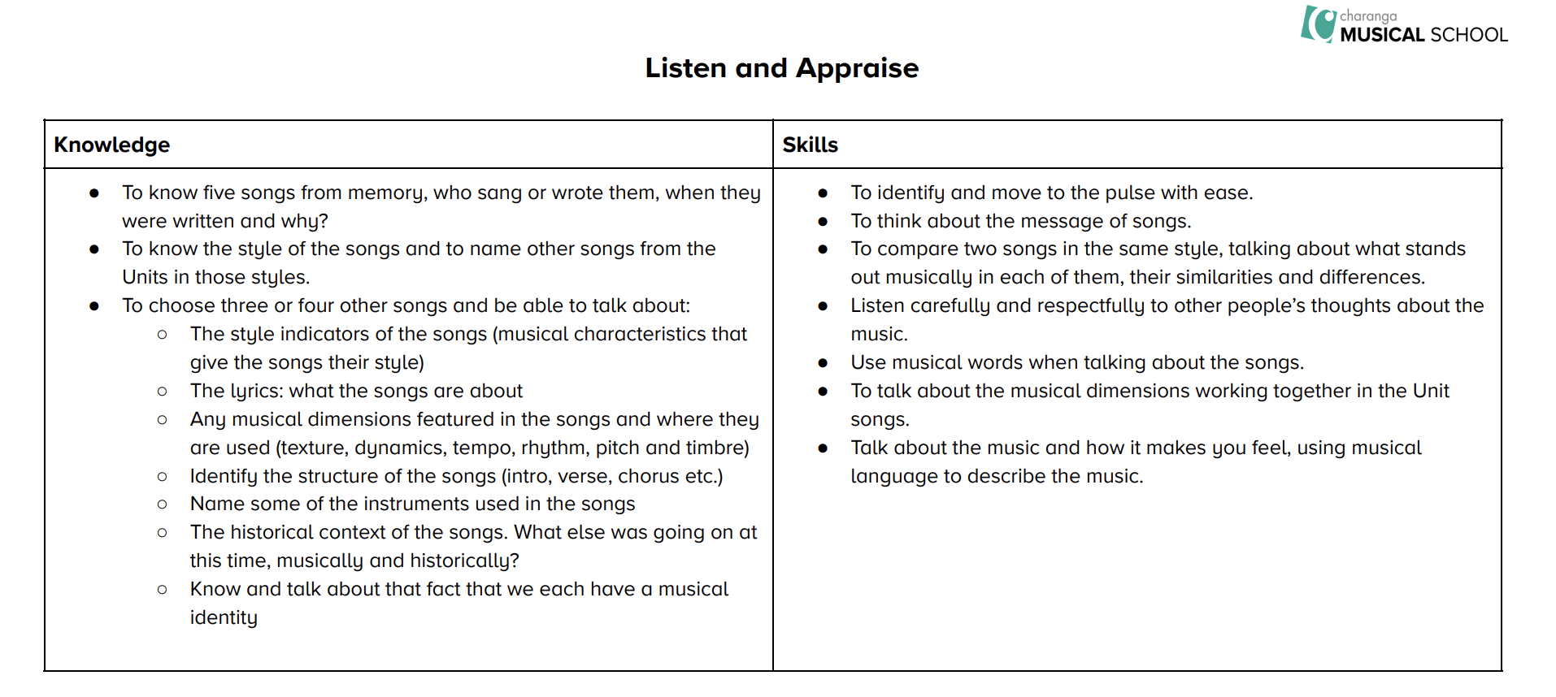

Charanga Music scheme – Year 6 Knowledge and Skills Assessment Overview

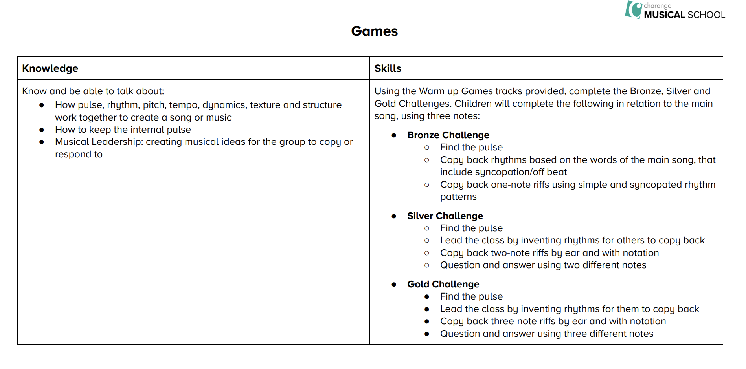

Charanga Music scheme – Year 6 Knowledge and Skills Assessment Overview

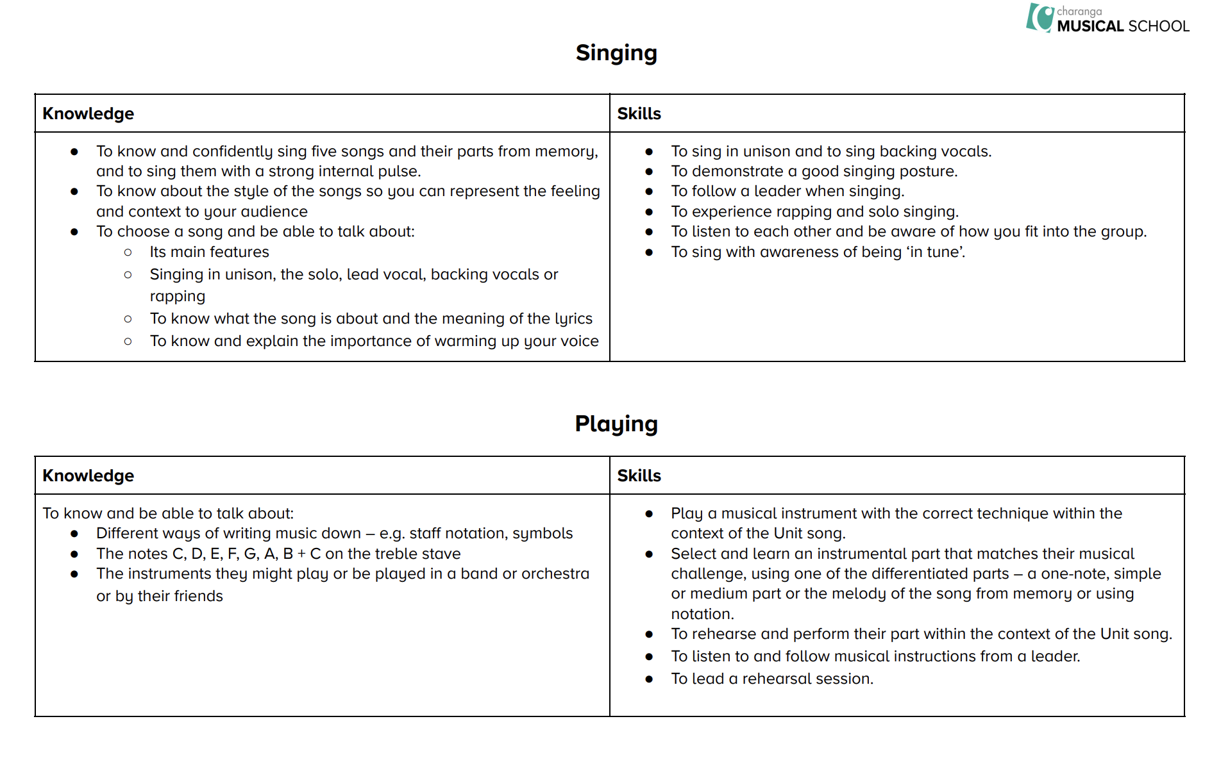

Charanga Music scheme – Year 6 Knowledge and Skills Assessment Overview

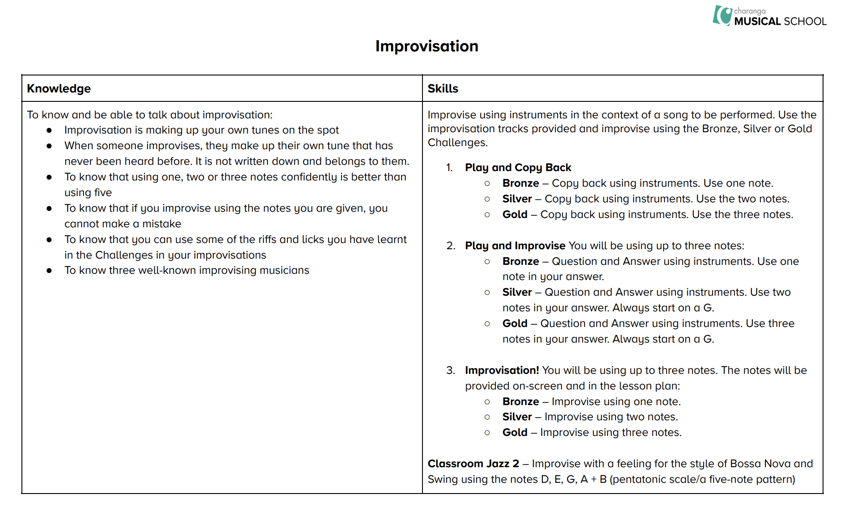

Charanga Music scheme – Year 6 Knowledge and Skills Assessment Overview

